Kylee Leingang
The Ocean Unit

True or False (1 point each): Declare whether the statements are correct by selecting true or incorrect by selecting false. Circle either T for true or F for false.
(T or F) You use a thermometer to measure the volume of an aquarium.
(T or F) There are 7 oceans on Earth.
(T or F) Alligators live in kelp forests.
(T or F) The Blue Whale is the largest living animal in the ocean.
(T or F) The Arctic Ocean is the smallest ocean.
(T or F) The Pacific Ocean is the largest ocean.

Fill in the blank (1 point each):
The Rainbow fish lived in the ____________.
The Rainbow fish was sad because ______________.
The Rainbow fish went to ____________ for advice.
The Rainbow fish felt ___________ at the end of the story.
___________ asked Rainbow fish for a shiny scale.

Matching (1 point each):
Coastal Sea turtles, coral, fish, and sea horses
Intertidal Anemones, kelp, and jellyfish
Sandy Shores Stick worm tubes and common littleneck clams
Rocky Shores Can survive both on land and in water which include turtles, birds, and crabs.
Mud Flats Sand Dwellers, birds, and plants
Kelp Forests Sea Urchins, Barnacles, and Blue-Green Seaweed
Coral Reefs Algae, crabs, and star fish

Multiple Choice (1 point each):
Image 1: 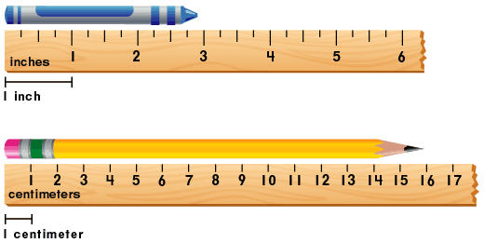
How long is the crayon in Image 1?
- 4 cm
- 3 in
- 3 cm
- 5 in
How long is the pencil in Image 1?
- 16 cm
- 25 cm
- 16 in
- 28 in
If the volume of an aquarium is 24 cubic feet. If the width of the tank is 4 feet and the length of the tank is 3 feet, what would be the depth of the tank?
- 2 ft
- 5 ft
- 7 ft
- 3 ft
If a fish needs to live in a tank at least 24 cubic feet, which tank would be okay for the fish?
- 2 feet long, 3 feet wide, 2 feet deep
- 1 foot long, 4 feet wide, 5 feet deep
- 5 feet long, 4 feet wide, 2 feet deep
- 2 feet long, 3 feet wide, 1 foot deep
The aquarium is 5 inches wide, 8 inches tall, and 6 inches deep. What is the volume of the aquarium?
- 240 cubic inches
- 19 cubic inches
- 30 cubic inches
- 100 cubic inches

Essay (5 points):
Describe the animal you chose for the “Who Will Win book” What supporting evidence did you use to defend your animal’s abilities?

Ocean
Content Outline | Knowledge | Comprehension | Application | Total | Percent
The student will describe the feelings of various characters in Rainbow Fish by Marcus Pfister. | 2 | 3 |  | 5
The student will create their own “Who Will Win?” book including facts, definitions and details of the animal they chose. |  |  | 1 | 1
The student will measure the volume of an aquarium based on the measurements of an aquarium they have designed. | 1 |  | 3 | 4
The student use a ruler to measure the dimensions of an aquarium they have designed. |  |  | 2 | 2
The student will identify the habitats and living conditions for marine life. |  | 6 | 1 | 7
The student will artistically create and design an aquarium including at least 3 types of marine life. |  | 2 |  | 2
The student will use a variety of resources to compare and contrast oceans. | 2 |  |  | 2
Total | 5 | 11 | 7 | 23
Percent | 21.7 % | 47.8 % | 30.5% |  | 100%

